Chapter 7, Problem 91.

The circuit in Fig. 7.150 is used by a biology student to study “frog kick.” She noticed that the frog kicked a little when the switch was closed but kicked violently for 5 s when the switch was opened. Model the frog as a resistor and calculate its resistance. Assume that it takes 10 mA for the frog to kick violently.

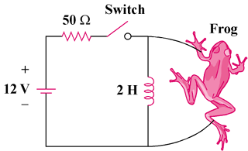

Figure 7.150
For Prob. 7.91.

